**Hitroo Online Course Application**

1. Super Admin
2. Professional
3. Provider
4. Presenter
5. Regulator
6. Reviewer

**SUPER ADMIN**

The super admin can create users of the Hitroo application and provide them access to the features of the application.

The super admin will create a profession name and category name under master codes as given in the figure. *The category label should be changed to the profession. The professional name could be selected by alphabetical search.*

**Create Profession and Category**

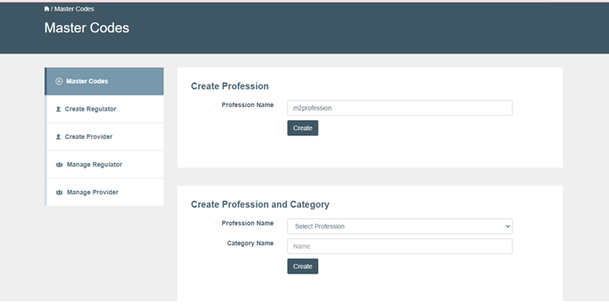

**Create Profession and Category Success**

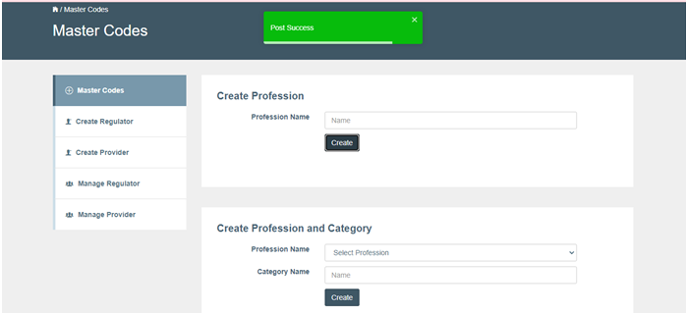

**Selecting Professional Name**

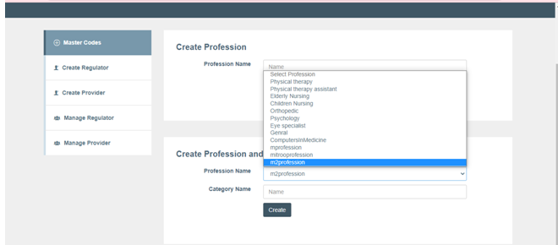

Super Admin will create a Regulator (who provide credits to the courses) by providing the Regulator name, Email ID, First Name, Middle Name, Last Name, Gender and state as given in the figure.

**Create Regulator**

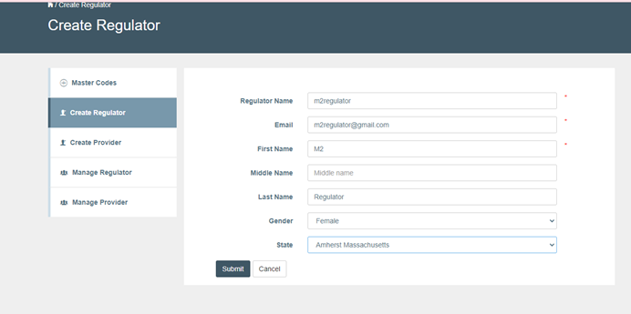

**Creating Regulator success**

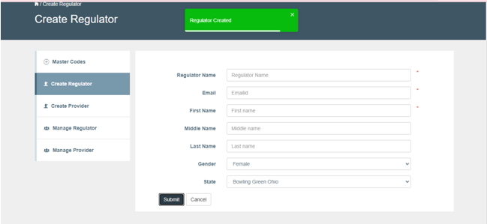

*The gender should be removed and the label state should be given as list of countries (US/ CAD), list of states under a country and list of cities under each state. Include the address details to be obtained from the regulator. The regulator mail id is the point of contact for obtaining any information from the regulator company. Obtain address details of regulator.*

The list of created regulators will be listed under manage regulator as given in the figure.

**Manage list of Regulators**

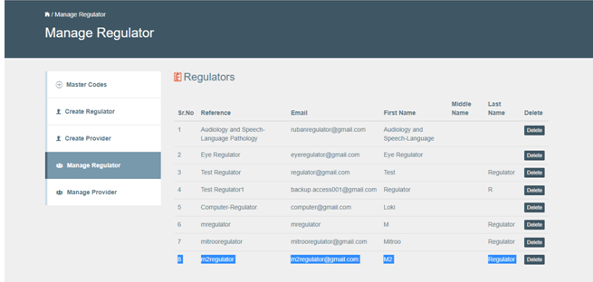

Super Admin will create a Provider (who provides the courses) by providing the Provider name, Email ID, First Name, Middle Name, Last Name, Gender and state as given in the figure.

**Create Providers**

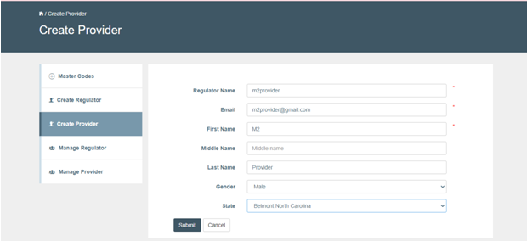

**Creating Provider success**

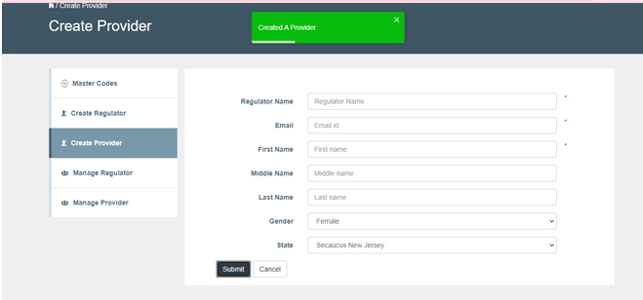

The label should be changed from Regulator Name to Provider Name. (*Bug to be corrected*)

*The state should be given as list of countries, following country, list of states and list of cities under each state. Gender field should be removed. Account creation of Provider should be self-serve like registration of profession. Provider should be able to sign up and create their own account.*

The list of created providers will be listed under manage provider as given in the figure.

**Manage list of Providers**

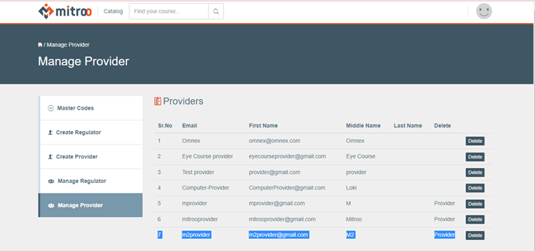

**PROVIDER**

The provider will login to provider account, the license update error will be displayer as shown in the figure which has to be addressed.

**Provider Account**

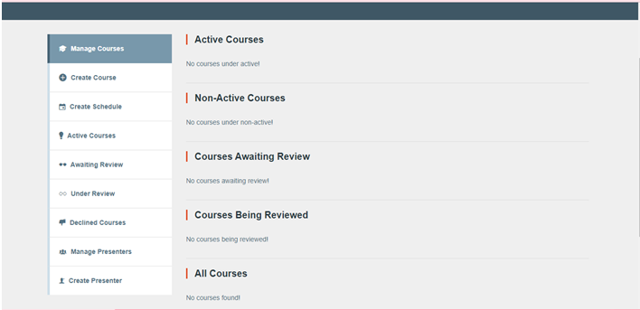

**Update License Information Error Pop Up**

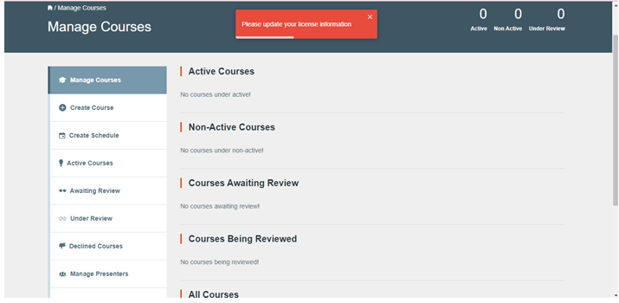

The provider will create the courses that are to be instructed by giving the course title, description, select related professions, categories, course content, additional course material as a pdf, course display image, price of the course (if it is not free), duration of the course in days, effort hours per day, select level from the drop down menu (Beginner, Intermediate, Advanced), select course type as certified or free and slug name same as course title with all small letters as shown in the figures.

**Create Course**

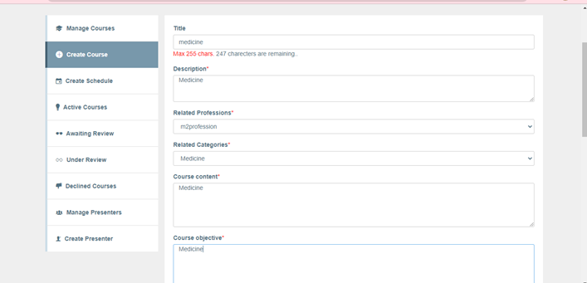

**Selecting Level of Course**

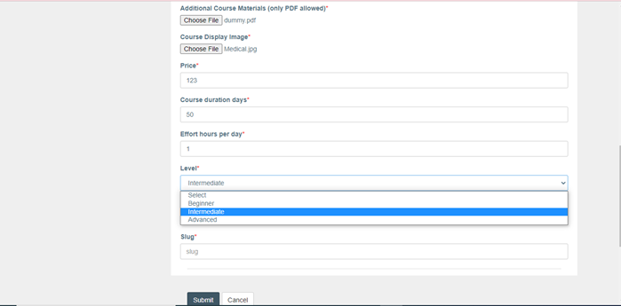

**Selecting Course type**

Course type: Certified / uncertified

Price: Free($0) or other amount greater than zero

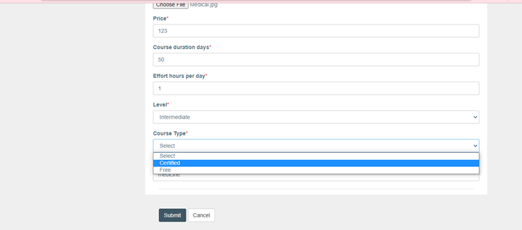

**Create Course success**

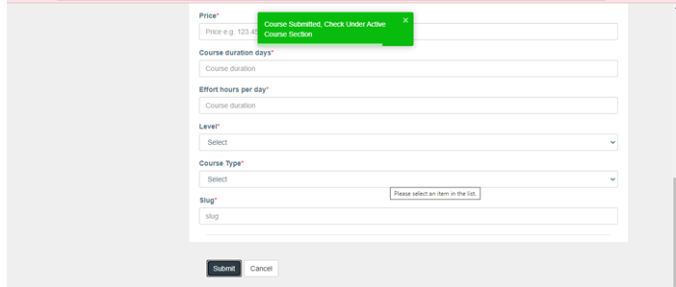

*If the course is free, the price field should be disabled and mention as the free course to the professionals under the price field. In such cases, the course type should only have certified and free should be removed. The following features should be included.*

1. *Slug is auto-created from the title of the course. If slug is already existing in the DB append with provider name*
2. *The list of professionals could be selected by alphabetical search.*
3. *Name and email of professional are mandatory.*
4. *Possibility of multiple account management for a single user should be allowed in order to switch between accounts.*
5. *A reviewer can act as a professional but there should be allowance for non-registered users to be invited by a regulator to register as a reviewer. Only a regulator can invite any user as a reviewer*
6. *~~Presenter can also act as a professional~~*
7. *If other users want to be registered as a professional, they have to use a different mail id while sign up.*
8. *The Feedback/survey/rating of each course should be given by the provider with the coordination of presenter.*
9. *The course price to be paid by the professional should be added to the cart and all the enrolled courses should be listed to the professional while checkout. If professionals log out before checking out the course(s) should remain in their cart.*
10. *The provider / presenter should be able to grade the professionals and provide the certificates to them.*
11. *Provider and presenter should be able to view the list of professionals enrolled for the course.*

Login to the provider account, click on the catalog and search for the course name and check the course credit points. The course points/credits will be updated if the regulator approves the course. The course schedule can be obtained from the schedule tab as shown in the figure.

**Approved Credits in the Provider account**

**Course Schedule**

Provider should post Q&A for the course. Provider or Presenter could be grading the Professionals as Pass / Fail.

*If the course needs to be edited later, the course should be cloned without making any modification to the already created course. If the course is to be edited by the provider, it must be edited.*

*.***Course Edit Option to Clone the Course by the Provider**

Once the course is created as shown in the figure, it is ready to be scheduled with the presenter.

**PRESENTER**

The provider could create a presenter (who instructs the course) by providing the Presenter Email ID, First Name, Middle Name, Last Name, Gender and state as given in the figure.

**Create Presenter**

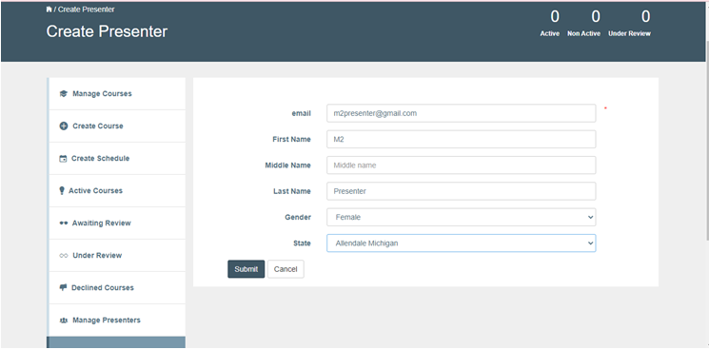

**Create Presenter Success**

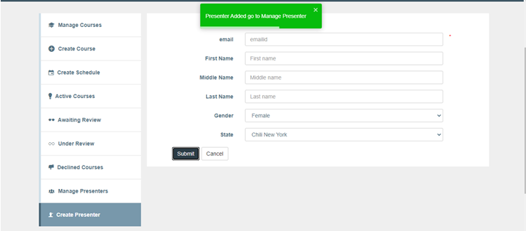

*The state should be given as list of countries, following country, list of states and list of cities under each state.*

The list of created presenters will be listed under manage presenter as given in the figure.

**Manage List of Presenters**

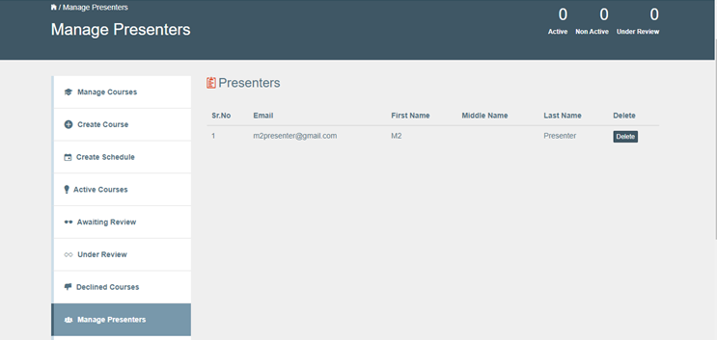

The provider schedules the course by selecting the following:

Course from the list of courses available,

Presenter,

Course format from the drop down (options are classroom training, training on demand, live virtual class),

Allowed attendance,

Course start and end date in the DD-MON-YYYY format,

State, start time and end time in HH:MM: AM/PM as shown in the figure.

The training is scheduled on successful scheduling of course as shown in the figure. *During course scheduling it is optional to select a presenter. There should be option to change the presenter for the scheduled courses. The start and end time while scheduling the training should be validated.*

**Create Schedule and select Presenters**

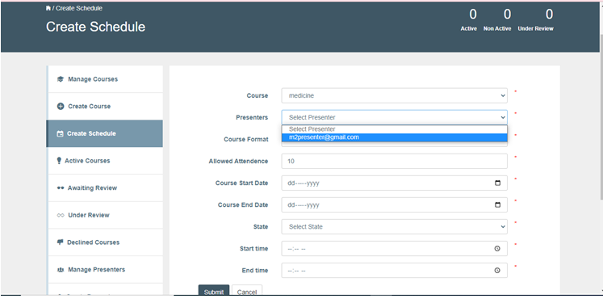

**Select Course Format**

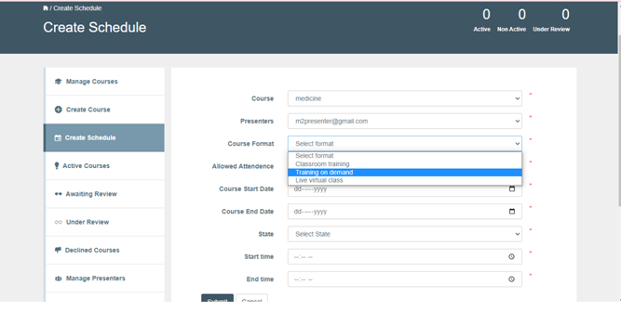

**Create Schedule**

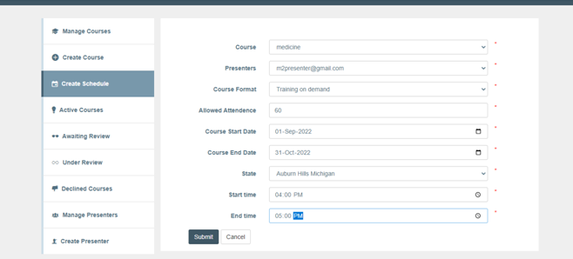

**Create Schedule Success**

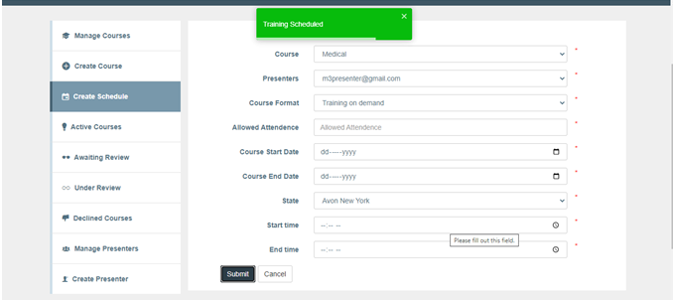

*The state should be given as list of countries, following country, list of states and list of cities under each state.*

Once the course is scheduled, the course will be available in the active courses and those courses are ready to be sent to the reviewer as shown in the figure.

**Active Courses**

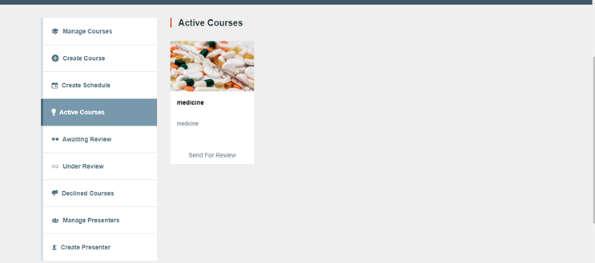

These active courses have to be submitted to the regulator for the reviewer to be assigned by the regulator. Change the reviewer name to the regulator (bug). *The regulator will send the course for review. A single course could be send to multiple reviewers by the regulator.*

*Every time provider submits the course to the regulator to be sent for review, the provider has to pay for each review process.*

Awaiting review tab will show the courses submitted to the review (submitted to the regulator for reviewer to be assigned) as shown in the Figure.

**Send for Review, Select Regulator (Submit to Regulator for assigning Reviewer)**

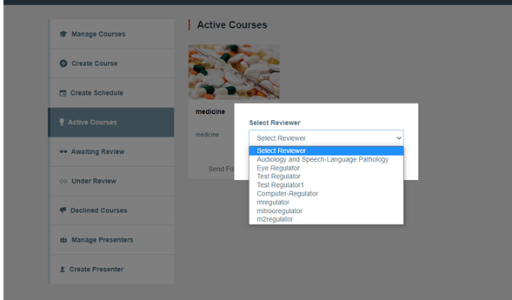

**Active Course after submission for Review**

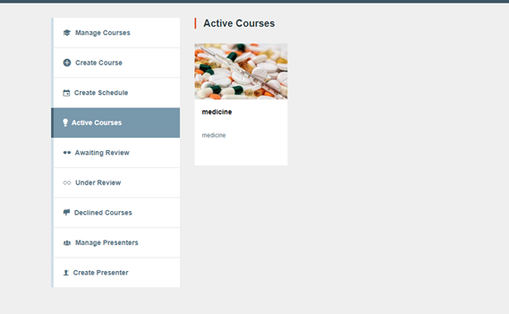

**Submission to Regulator Success**

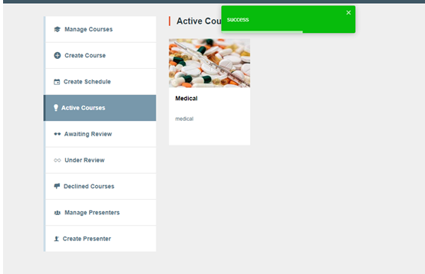

**Course Awaiting Review**

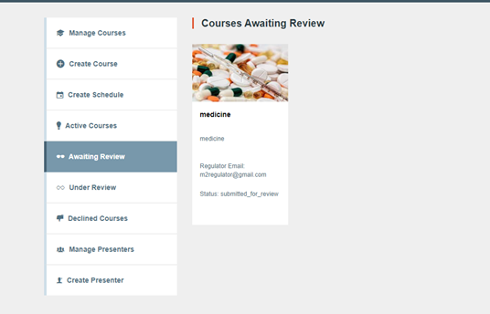

Under review tab will list the courses which was assigned to the reviewer by the regulator. Declined courses by the regulator will be displayed in the declined courses tab.

**PROFESSIONALS**

The professionals are the users who take up courses related to their profession to gain credits.

Initially the professional must sign up to the application with an Email ID and password. Login as new professional, search in the catalog for the courses, check with the course credits, enrolls for the course and the new professional will attend the course as shown in the figure.

**Professional Sign up**

**Professional Sign up Success**

**Professional login**

The Professional will update their profile with personal and contact information. They could add the license, education and employment details as shown in the figures given below.

**Personal Details**

**Contact Details**

**License information**

**Update Education Information**

**Update Employment Information**

In the Hitroo application, the professional could search for the approved courses in the professional dashboard. Professionals could search for courses based on the following aspects.

By location,

By category.

Professionals will enroll for the courses approved by the regulator and reviewer. Professionals could enroll for the credit-based courses, noncredit-based courses and free courses which are available to them and attend the registered courses offline. The professional will act as a reviewer to review the courses and the professional dashboard should have an option to change role from professional to reviewer and vice versa. The enrolled professionals should be visible to both provider and presenter.

**Catalog Search for courses**

**Professionals check credits and enroll for the course**

**REGULATOR**

The regulator will assign reviewers to the courses. Unassigned courses will be listed under new courses. The regulator could create a reviewer (who reviews the course) by providing the reviewer Email ID, First Name, Middle Name, Last Name, Gender and state as given in the figure.

**Regulator Login, Create Reviewer from Professionals**

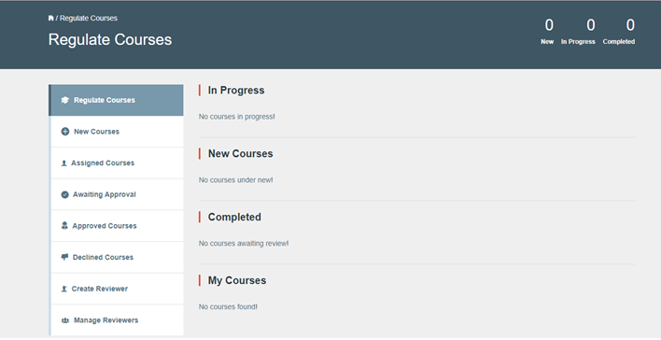

**Update License information error pop up**

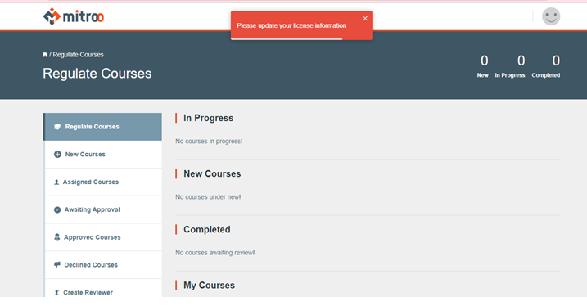

**New Course submitted to Regulator**

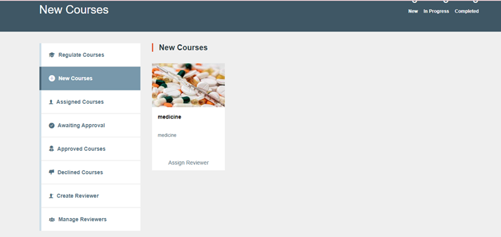

**Creating Reviewer**

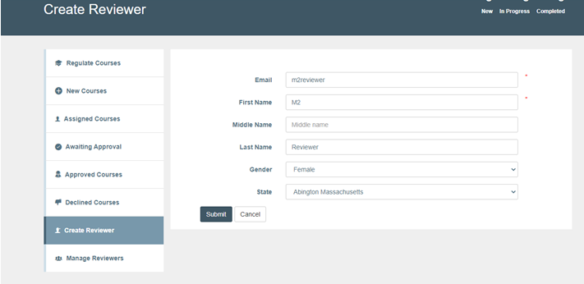

Note that the reviewer is one of the professionals already registered with Hitroo who will review the course.

**User already as Reviewer**

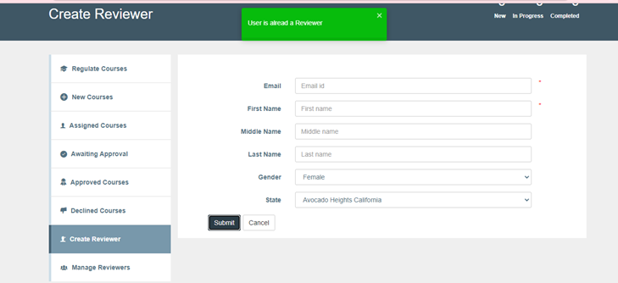

**Manage List of Reviewers**

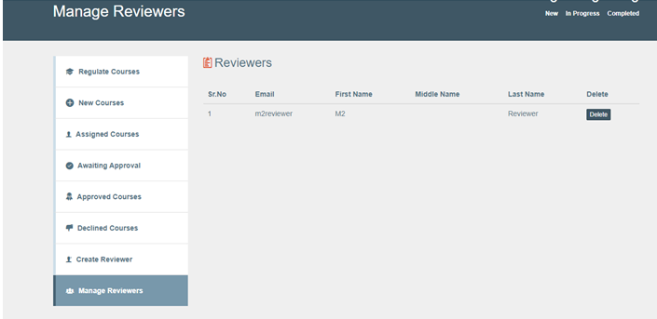

The existing professional should be given as the reviewer as shown in the figure.

**Reviewer Name and Mail ID as existing Professional**

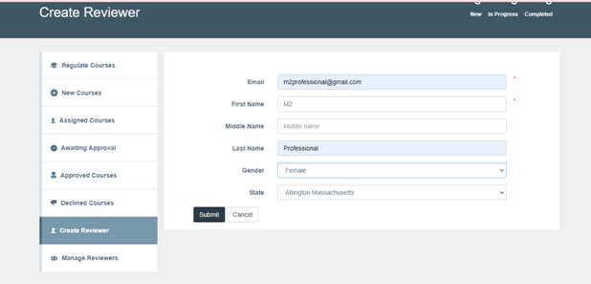

**Professional made as Reviewer**

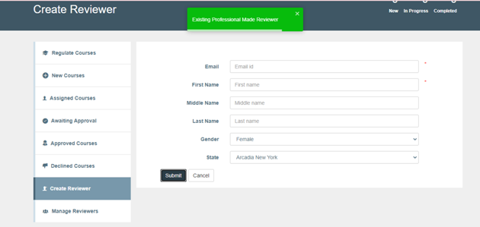

A new reviewer can also be created but they could not assigned as reviewer unless they are a registered as a professional as shown in the figure.

**Creating Reviewer who is not a Professional**

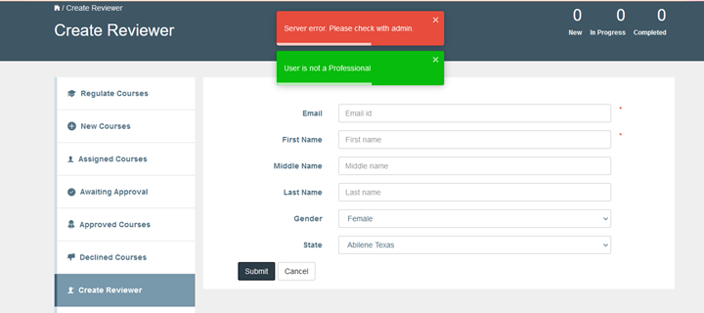

**Existing Professional made as Reviewer**

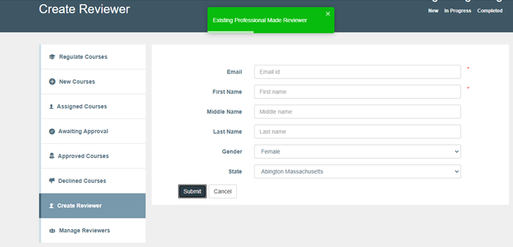

*The state should be given as list of countries, following country, list of states and list of cities under each state.*

The list of created reviewers will be listed under manage reviewer as given in the figure.

**Manage list of reviewers**

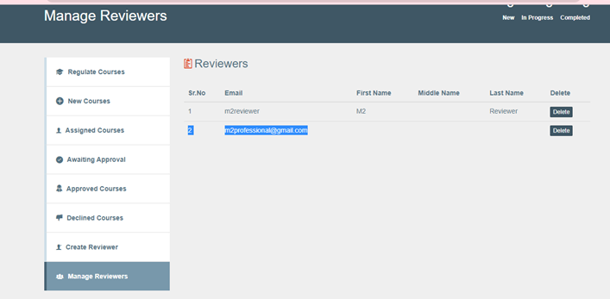

After creating the reviewer, the regulator will assign the reviewer to the New Course by clicking on assign reviewer and selects the created reviewer from the drop down list as shown in the figure.

**Assigning Reviewer**

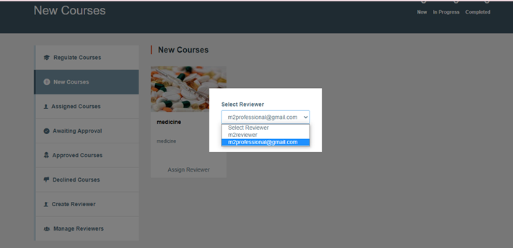

Once the reviewer is assigned for the course, it will be under awaiting for the approval from the regulator as shown in the figure.

**Awaiting Approval from Reviewer and Regulator**

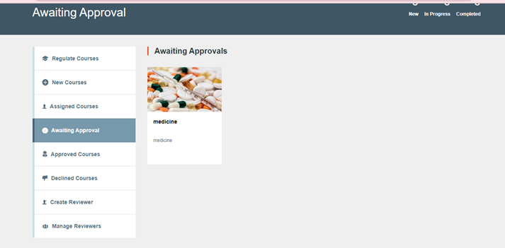

The regulator will either approve or reject the course based on the review comments and credits provided by the reviewer. In the Awaiting approval tab, the course details can be viewed. In the validation tab of the course, the reviews submitted by the reviewer will be visible. The regulator will approve or decline by selecting the option form the drop down list (Review again, approve, set back to created, decline). If the regulator approves the course the credit points will get updated for the course under validation tab of the corresponding course as shown in the figure. Otherwise, the credit point will be still zero until regulator approves the course.

**Awaiting Approval from Regulator**

**Regulator Approve / Decline**

**REVIEWER**

Reviewer will review the course and provide credits. Login to reviewer account and update license information pop up comes out for every single login. The professional is now called as a reviewer. The reviewer clicks on the Assigned Courses (tab) for review and navigate to the validation tab (The course details will have the approved credits to be zero initially before review.). In validation tab, the reviewer will do the following:

Approve or decline,

Provide credits points and

Remarks as shown in the figure.

**Reviewer Login**

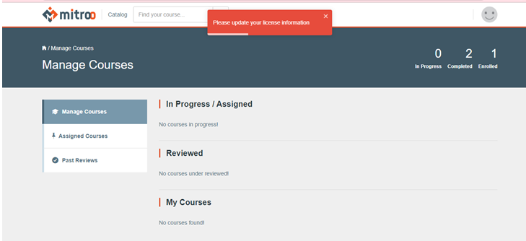

**License update information error pop up**

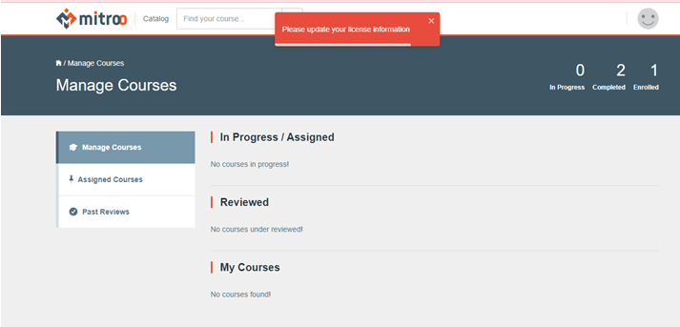

**Assigned courses for Review**

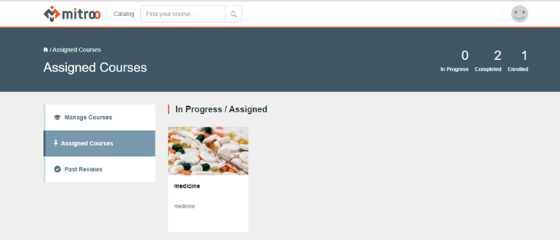

**Approved Credits as zero Initially**

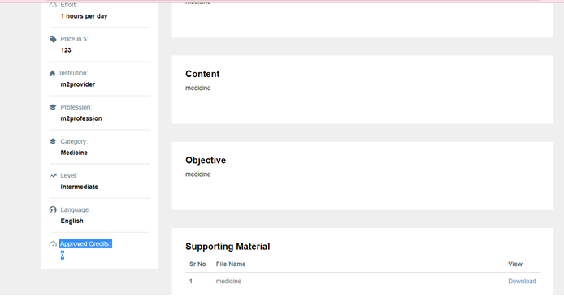

**Reviewer Validating the Course (Approve / Decline)**

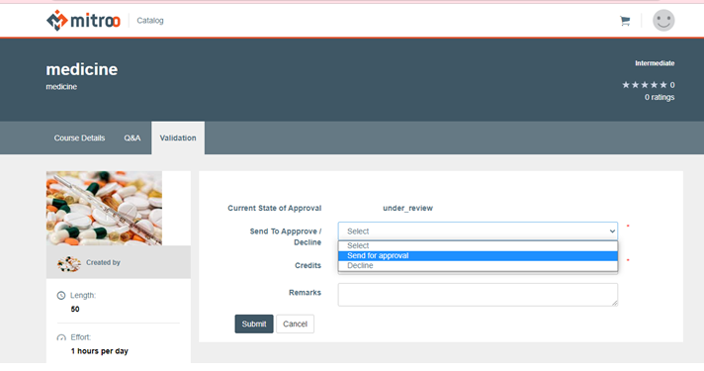

**Reviewer providing Credits and Remarks of the Course**

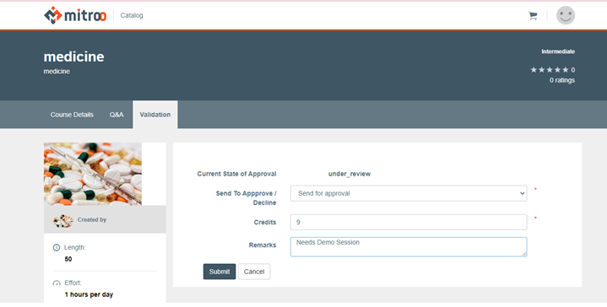

**Reviews sent by Reviewer**

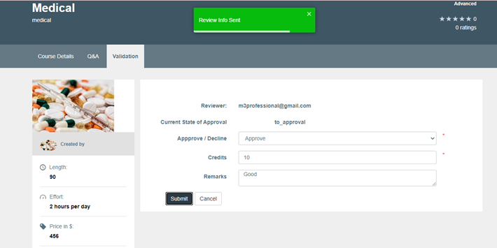

**Review info is sent**

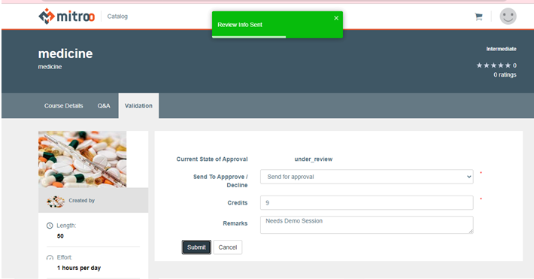

*The remarks field should allow formatting of the text and provision to add images and figures.*

The approved course by the reviewer will be submitted back to the regulator for further action as shown in the figure as Review info sent.

The list of previously reviewed courses by the reviewer will be listed in the past reviews as shown in the figure.

**List of Past Reviewed courses**

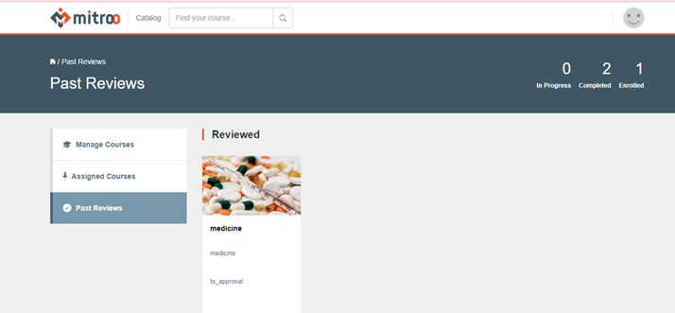

Once the reviewer provided the credits, review comments and approves the course, the regulator will either approve / decline the course based on the remarks submitted by the reviewer.

The approved and declined courses will be listed in the approved courses and Declined courses tab of the regulator account.

The credit points of the approved courses will be reflected in the course details of the provider account as shown in the figure.

**Approved Credits updated**

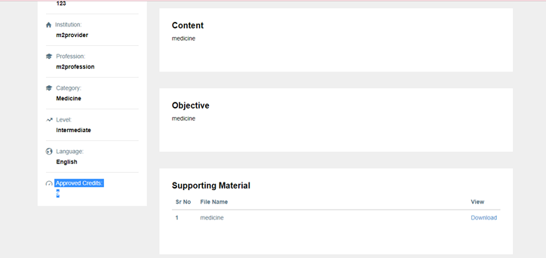

**Clarifications:**

* The license information update pops up for all type of users of Hitroo application upon login. Who must update the license information?
* *Account creation of Provider should be self-serve like registration of profession?*
* *Every time provider submits the course to the regulator for review, the provider has to pay for each review process..? if yes need details.*

if required we will provide an option for the user to register as a professional/provider/regulator. If the user wants to register as a provider or regulator then after the signup request submission he will receive a mail saying his request is awaiting Admin's approval. And admin will approve the request based on any background checks required (The background checks will be out of scope in this application i.e., they will be taken care of in the backend)

Along with the credit points approval, we will also provide an option for the regulator to provide the license validity period for the completion of that course say like upon completion of the course the license will be valid for 1 year then there will be no need for the regulator to track the license manually. Because upon course completion the validity of the license of the professional would get extended by default

We will integrate a payment gateway for the payment to be handled. Once the user selects the course and adds it to the cart he will be requested for payment. Once we get success response for payment completion from the payment gateway then we will provide the access to the course for the user, The same process will be followed when a provider wants to send a course for approval to the regulator.

We will provide an option to the presenter and provider to update the percentage completion and successful completion option of the course of the user based on his participation. Once the user gets a certain percentage completion count then there will be an option to get the course completion certificate. This way provider and presenter will be able to track each individual's course completion.

The transcript

The transcript consists of all the courses the professional has done in the licensing period. The transcript will have the courses that are only relevant to that licensing period. On the transcript page, the professional should be able to view previous transcripts from previous licensing periods. the professional should be able to view the transcript and to be able to generate a PDF version of the transcript.

When courses are completed the **provider** or the **presenter** will close out the course by grading or setting the attendance to the course as completed for each participant of that course. So for grading test, there should be a page where the **presenter** or participants can view all the list of the courses the **professionals** took and certify that they completed the course(s).

The transcript will have a unique identifier that can be used to generate the same transcript again so that where ever that transcript is sent, the transcript can be verified on the site to generate the exact same copy of that transcript.

The **regulator** that receives the transcript should be able to validate the transcript from the site.

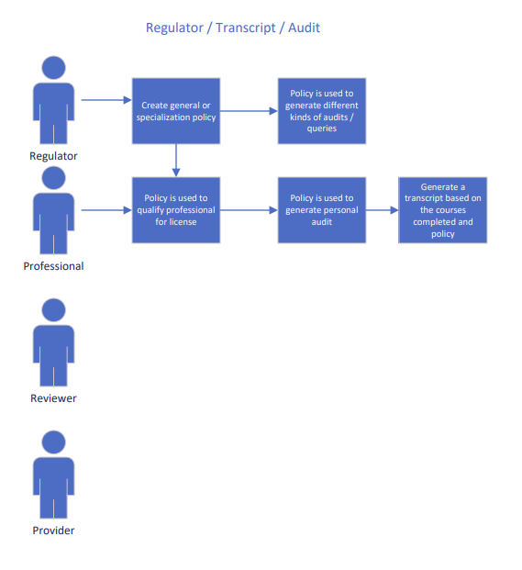

**My audit**

My**audit** link is to show the professional has x amount of course credit units completed and x amount of ccu remaining to be qualified for a new license. The professional should be able to see how many courses are still left or if the requirements associated with the **regulators** licensing policy have been met.

This aspect of the solution will also be the part that sends the user notifications based on the amount of CCU uncompleted and or if the user has met all the course requirements needed to be qualified for a new license.

The **regulator** should also be able to audit all the accounts of users registered to their association, in order to validate who has not met their licensing obligation based on the time that their licenses will expire. There should be options for different search criteria based on time, qualification for new licenses, unqualified users past their license expiration date.

**Overall Flow Diagram**

Create and Manage Reviewer (Existing Professional)

Switching between Professional and Reviewer accounts

Pay for every review submission

Create and Manage Presenter.

Presenter can also be Professional. Switch between accounts

Monitors All Users

(Professionals, Provider, Presenter, Regulator, Reviewer)

Create and Manage Regulators

Create and Manage Master Codes

Create and Manage Providers

Check Course details, Schedule and credits

Update Profile Details

Search Catalog for courses

Enroll for the course

Provider Checks Approve/Decline course and credit points earned

New Professional Sign in

Regulator Approve / Decline Course

Review the course, provide credits and remarks

Submit Reviews to the Regulator

Submit course to Reviewer for review

Awaiting for the Review

Submit course to Regulator

Schedule Course and assign Presenter

Create and Manage Courses